**Project Design Phase-II**

**Data Flow Diagram & User Stories**

|  |  |
| --- | --- |
| Date | 03 October 2022 |
| Team ID | PNT2022TMID48513 |
| Project Name | Project – IOT based smart crop protection system for agriculture |
| Maximum Marks | 4 Marks |

**Data Flow Diagrams:**

A Data Flow Diagram (DFD) is a traditional visual representation of the information flows within a system. A neat and clear DFD can depict the right amount of the system requirement graphically. It shows how data enters and leaves the system, what changes the information, and where data is stored.

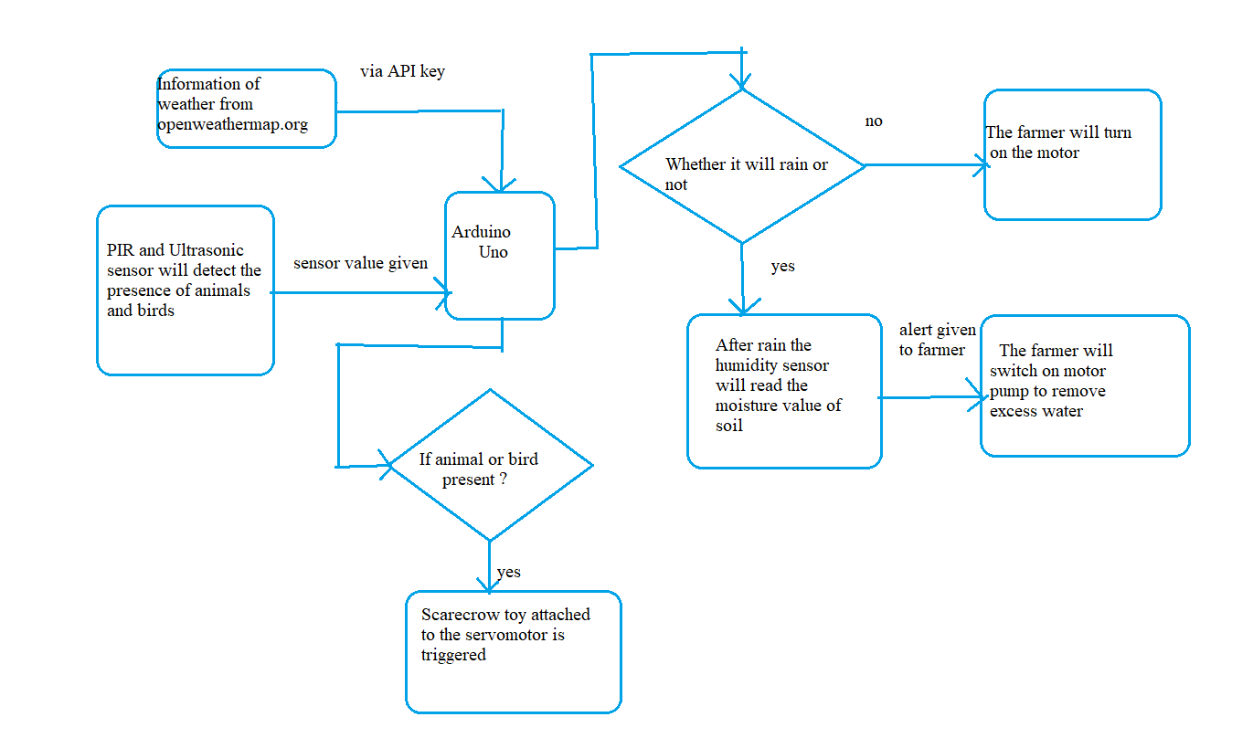

**User Stories**

Use the below template to list all the user stories for the product.

| **User Type** | **Functional Requirement (Epic)** | **User Story Number** | **User Story / Task** | **Acceptance criteria** | **Priority** | **Release** |
| --- | --- | --- | --- | --- | --- | --- |
| Customer (Mobile user) | Registration | USN-1 | As a user, I can register for the application by entering my email, password, and confirming my password. | I can access my account / dashboard | High | Sprint-1 |
|  |  | USN-2 | As a user, I will receive confirmation email once I have registered for the application | I can receive confirmation email & click confirm | High | Sprint-1 |
|  |  | USN-3 | As a user, I can register for the application through Gmail | I can receive verification code and invitation | Medium | Sprint-1 |
| Administrator | Login | USN-4 | As a user, I can log into the application by entering email & password | I can login to my account | High | Sprint-1 |
| Weather | Checking | USN-5 | Weather forecast for that day can be seen. | I am getting notified about the weather changes | High | Sprint-2 |
| Moisture level | Checking | USN-6 | Humidity sensor value can be seen | I can view the data given by the device | High | Sprint-2 |
| Control Pump | Controlling | USN-7 | It is used to control the motor pump | I can on and off the motor via mobile | High | Sprint-3 |
| Motion Detection | Detecting | USN-8 | The presence of animals and birds in the field is detected. | I can see the sensor values in mobile | High | Sprint-3 |
| Toy Triggering | Triggering | USN-9 | Upon the presence of animal or bird , the toy at that spot will be triggered | I can trigger the toy via mobile | High | Sprint-4 |
|  |  |  |  |  |  |  |
|  |  |  |  |  |  |  |